IP-Touch terminal with LEGIC/DESFire reader
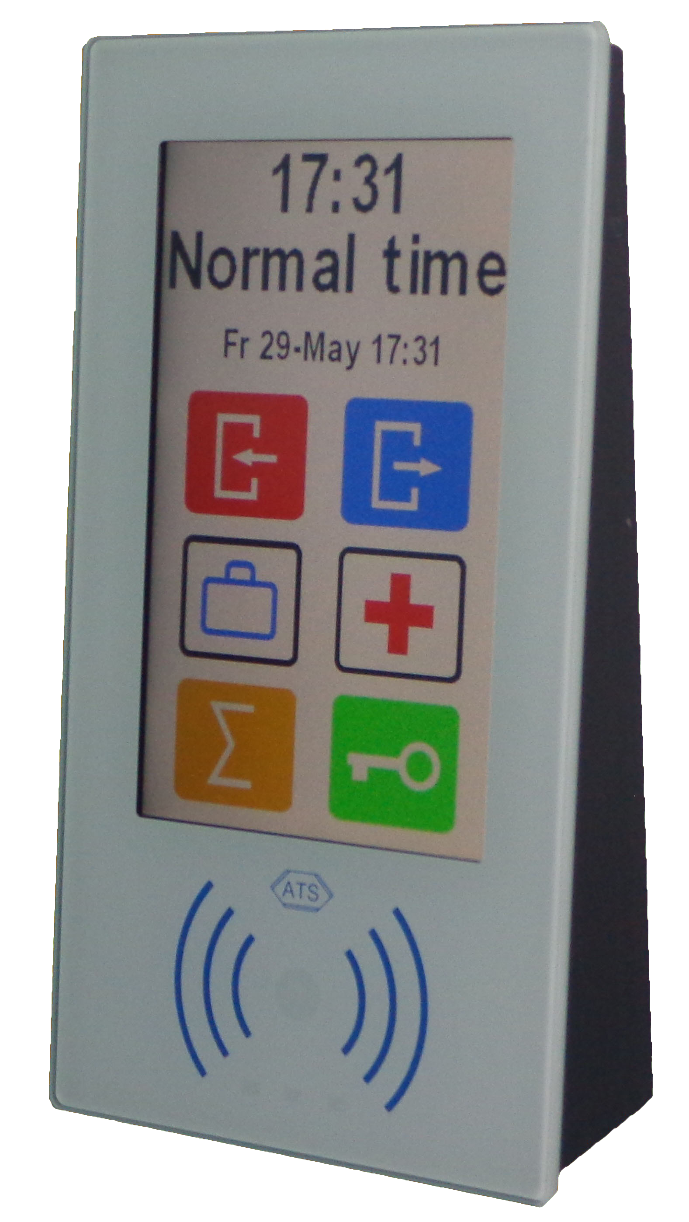

DIGIterm-350
ATS
HIGH-TECH SECURITY PRODUCTS MADE IN AUSTRIA

- T&A and control terminal with encrypted RFID reader
- 10/100 Mbit POE Ethernet interface
- Mifare/DESFire & LEGIC read/write RFID reader
- 5” touch screen with brilliant colour display
- Configurable user interface
- 20 pages with up to 14 loadable icons
- Single IBB for up to 19 remote devices
- T&A for 5000 cards per terminal
- Access control management for up to 15000 cards
- SD-card reader for offline data storage
- Integrated buzzer & 3 status LED’s

DIGIterm-350 T&A and application terminal
ATS
Information contained in this document is correct at time of publication (250915) and subject to change without notice.
Austrian Technical Systems
Werk Wienerwald +43-2238-700-05, Fax +43-2238-700-05-210 http://www.ats.co.at

The outstanding design of the DIGIterm-350 makes time recording easy. The advanced multifunction T&A and control panel with an encrypted LEGIC-Advant & Mifare/DESFire read/write unit has an glass surface design with capacitive touch sensor technology. The glass only front ensures an easy cleaning and long lifetime without any symptoms of age.
The 5” touchscreen with a brilliant colour display has the possibility to completely adapt the screen layout and functions according to your needs.
Up to 20 screen pages with a maximum of 16 icons and function could be configured individually with a resolution of 800x480 dots. There are functions for T&A, Alarm system, light control, regulation, fire alarms and many more. All functions can be restricted by per user through ID card and PIN code. Three status LED’s, a buzzer and a 3 colour reader LED increase user comfort and diagnostic possibilities.
The graphic icons for in, out, official absence and balance query, are easy to use by the employees. A message box allows to drop special messages to an individual, a group, ore to all members of the company.
A SD card reader and CMOS clock allows to store bookings over a long time, in case of network interruption.
Surprisingly you can do more with the terminal, than just registration times. Be inspired and use all options to optimise communication with the processes relating to the people in your company.
A special message buffer allows to leave individual or generic messages to the employees, which will be displayed together with the acknowledgement of the booking.
But these are not the only exiting possibilities. The DIGIterm-350 is also a small Floorcontroller.
The terminal is featuring a single Intelligent Building Bus (IBB), to act as a small Floorcontroller. DIGIterm-350 is also an access controller for up to 15.000cards, an alarm system, a light control and regulation system for one area (optional extendable to five).
Full 256Bit AES encryption for communication to the host allows to connect the terminal over the internet without any risk. In order to keep installation and power costs down, the terminal is could be connected over POE Ethernet. Alternative it could be supplied with external 12-24VDC or over the IBB bus from a door control box (for example a DIGIcontrol-PR+) with battery backup.
The DIGIterm-350 comes with a wall fastening panel which allow easy installation of the slim terminal with just four screws. AN optional in wall box allows a complete flat mounting, similar to the ATS light switches.
The “LockLink” option integrates offline door components to your online access solution.
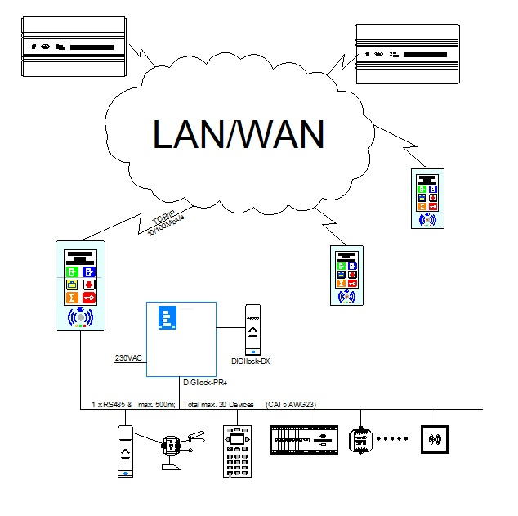

Technical Data
DIGIcontrol-350:
32 Bit 800Mhz ARM Cortex-9 CPU with Lithium battery buffered CMOS clock;
256MB SDRAM, 128MB Flash memory,
5” Graphic Touch Display
Mifare/DESFire & LEGIC-Advant encrypted RFID reader/writer
5- 40mm reading distance
SD-Card reader for long time data storage
10/100Mbit POE interface
Integrated buzzer
1 Aktiv RS485 Intelligent Building Bus (IBB)
Temperature range: -10° to +50°C
Out wall Dimensions: W95 x H173 x 42mm
Power: 3W from POE or 10,5-24VDC
Delivery Contents:
DIGIterm-350 complete with mounting plate, installation and wiring instructions.
Options:
DIGIcontrol-FC1
Licence Extension key for DIGIterm-350 to add one extra area (max. 5 areas in total).
DIGIcontrol-LL
LockLink option to update RFID cards for
offline locks.
Variants:
DIGIterm-350/P
125kHz DIGIid-INT/IKT reader instead of DESFire/LEGIC reader.

